**Hands-on 1**

**Create a Spring Web Project using Maven**

**Steps:**

1. Go to <https://start.spring.io>.
2. Set Group as com.cognizant and Artifact as spring-learn.
3. Select dependencies: Spring Boot DevTools and Spring Web.
4. Generate and download the ZIP file.
5. Extract the ZIP to a suitable workspace folder.
6. Open Spring Tool Suite 4 (STS4).
7. Go to File > Import > Maven > Existing Maven Projects, and import the extracted folder.
8. Run the project with mvn clean package.
9. Open SpringLearnApplication.java, add a print line to the main() method.
10. Right-click and run SpringLearnApplication.java as a Java Application.

**Output:**

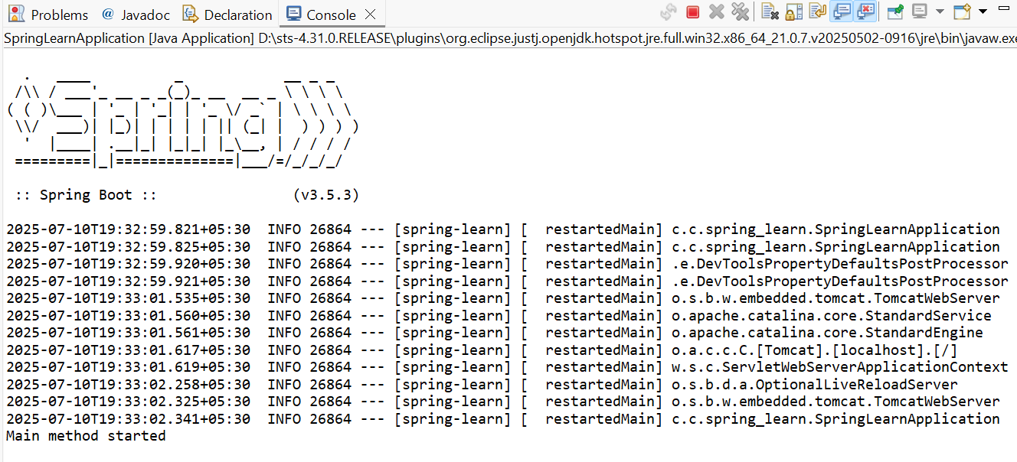

**Hands-on 4**

**Spring Core – Load Country from Spring Configuration XML**

**Steps:**

1. Create a Country class with code and name properties, constructor, getters, setters, and toString() method.

package com.cognizant.spring_learn;

import org.slf4j.Logger;

import org.slf4j.LoggerFactory;

public class Country {

private static final Logger *LOGGER* = LoggerFactory.*getLogger*(Country.class);

private String code;

private String name;

public Country() {

*LOGGER*.debug("Inside Country Constructor.");

}

public String getCode() {

*LOGGER*.debug("Inside getCode()");

return code;

}

public void setCode(String code) {

*LOGGER*.debug("Inside setCode()");

this.code = code;

}

public String getName() {

*LOGGER*.debug("Inside getName()");

return name;

}

public void setName(String name) {

*LOGGER*.debug("Inside setName()");

this.name = name;

}

@Override

public String toString() {

return "Country [code=" + code + ", name=" + name + "]";

}

}

1. Add debug logs inside the constructor, setters, and getters of the Country class.
2. Create a country.xml file in src/main/resources and define the country bean with code and name.

<?xml version="1.0" encoding="UTF-8"?>

<beans xmlns="http://www.springframework.org/schema/beans"

xmlns:xsi="http://www.w3.org/2001/XMLSchema-instance"

xsi:schemaLocation="

http://www.springframework.org/schema/beans

https://www.springframework.org/schema/beans/spring-beans.xsd">

<bean id="country" class="com.cognizant.spring_learn.Country">

<property name="code" value="IN" />

<property name="name" value="India" />

</bean>

</beans>

1. In SpringLearnApplication.java, create a displayCountry() method.

package com.cognizant.spring_learn;

import org.springframework.boot.SpringApplication;

import org.springframework.boot.autoconfigure.SpringBootApplication;

import org.slf4j.Logger;

import org.slf4j.LoggerFactory;

import org.springframework.context.ApplicationContext;

import org.springframework.context.support.ClassPathXmlApplicationContext;

@SpringBootApplication

public class SpringLearnApplication {

private static final Logger LOGGER = LoggerFactory.getLogger(SpringLearnApplication.class);

public static void main(String[] args) {

SpringApplication.run(SpringLearnApplication.class, args);

displayCountry();

}

public static void displayCountry() {

LOGGER.info("START");

ApplicationContext context = new ClassPathXmlApplicationContext("country.xml");

Country country = context.getBean("country", Country.class);

LOGGER.debug("Country: {}", country.toString());

LOGGER.info("END");

}

}

1. In this method, load the ApplicationContext using ClassPathXmlApplicationContext.
2. Get the country bean using context.getBean(...) and log the country object.
3. Call displayCountry() from the main() method.
4. Add proper logging configuration in application.properties.

spring.application.name=spring-learn

logging.level.com.cognizant.spring_learn=DEBUG

logging.pattern.console=%d{yyMMdd}|%d{HH:mm:ss.SSS}|%-20.20thread|%5p|%-25.25logger{25}|%25M|%m%n

1. Run the application and verify constructor, setter, and bean details in the console logs.

**Output:**

